NAME : DHARISHA G
TECH STACK:FRONTEND-REACT

SQL QUERIES:
1. Employee Table (CRUD Operations)*
* Create an *Employee* table.
CREATE TABLE Employee (
EmpID INT PRIMARY KEY,
EmpName VARCHAR(50),
Department VARCHAR(30),
Salary INT,
Age INT
);
* Insert at least *10 employee records*
INSERT INTO Employee VALUES (101,'Rahul','IT',55000,24), (102,'Priya','HR',45000,26), (103,'Arun','Finance',60000,30), (104,'Sneha','IT',70000,29), (105,'Kiran','Sales',50000,27), (106,'Divya','HR',48000,25), (107,'Vijay','Finance',75000,31), (108,'Anu','Sales',52000,23), (109,'Ravi','IT',65000,28), (110,'Meena','Marketing',58000,27);
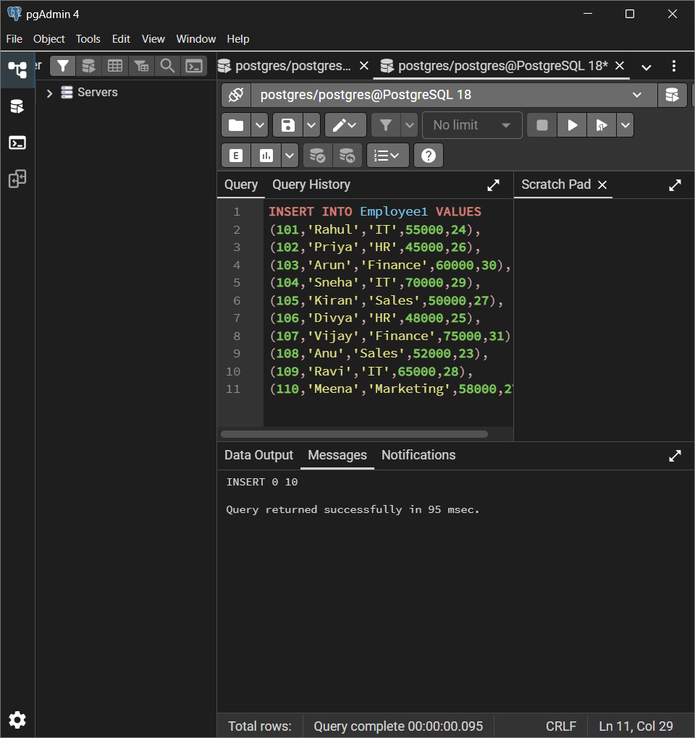
* Display all records.
SELECT FROM * Employee1;
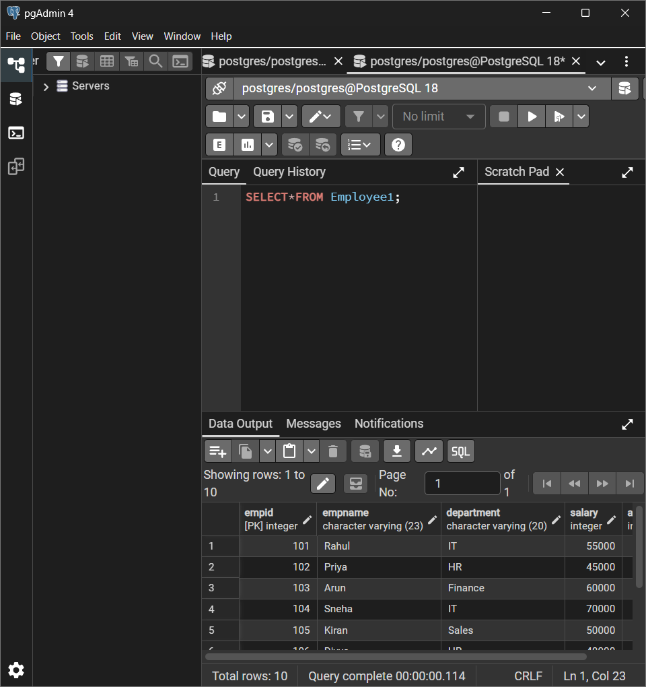
* Update an employee's salary.
UPDATE Employee1
SET Salary = 80000
WHERE EmpID=104;
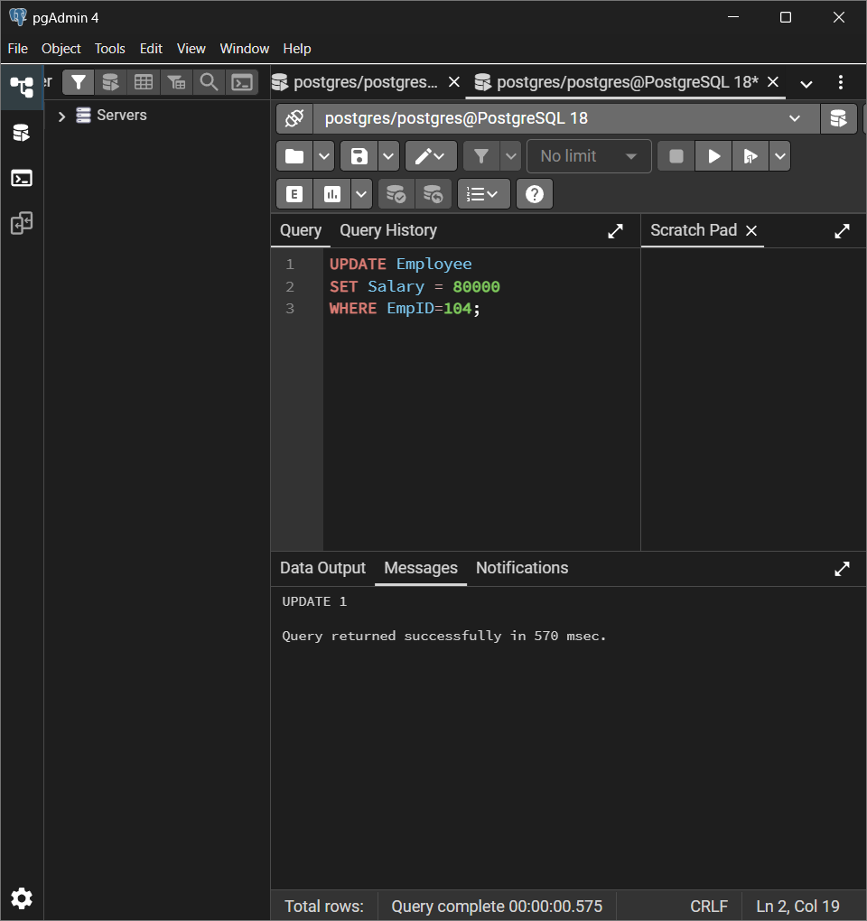
* Delete one employee record.
DELETE FROM Employee1
WHERE EmpID=105;
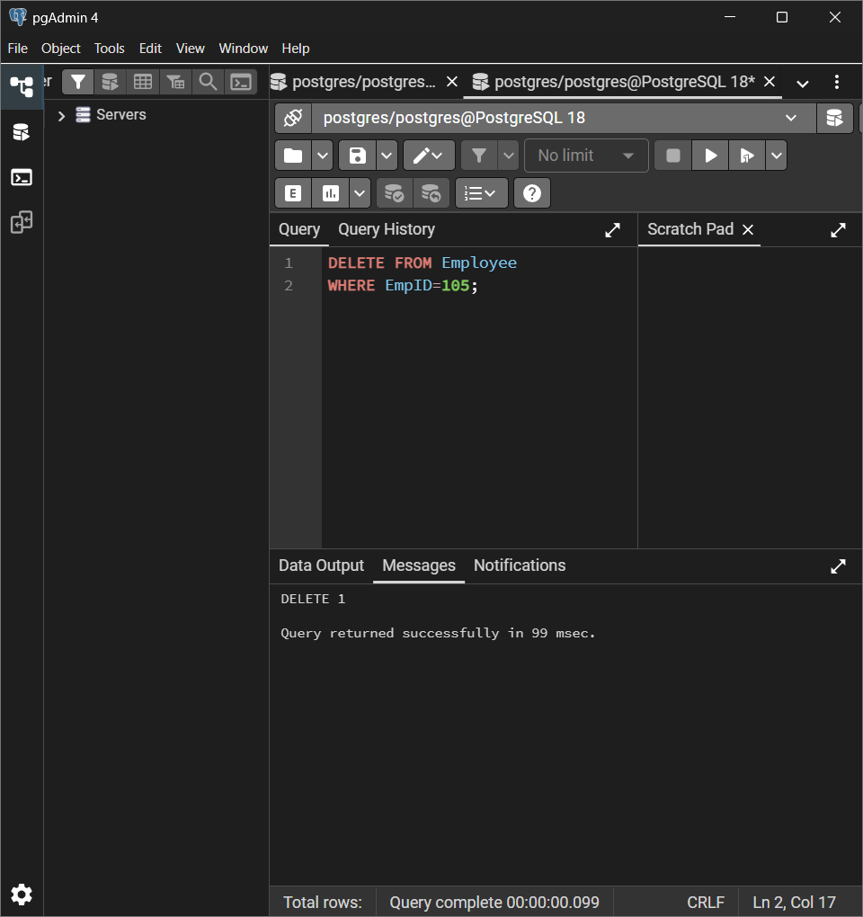
* Drop the table.
DROP TABLE Employee1;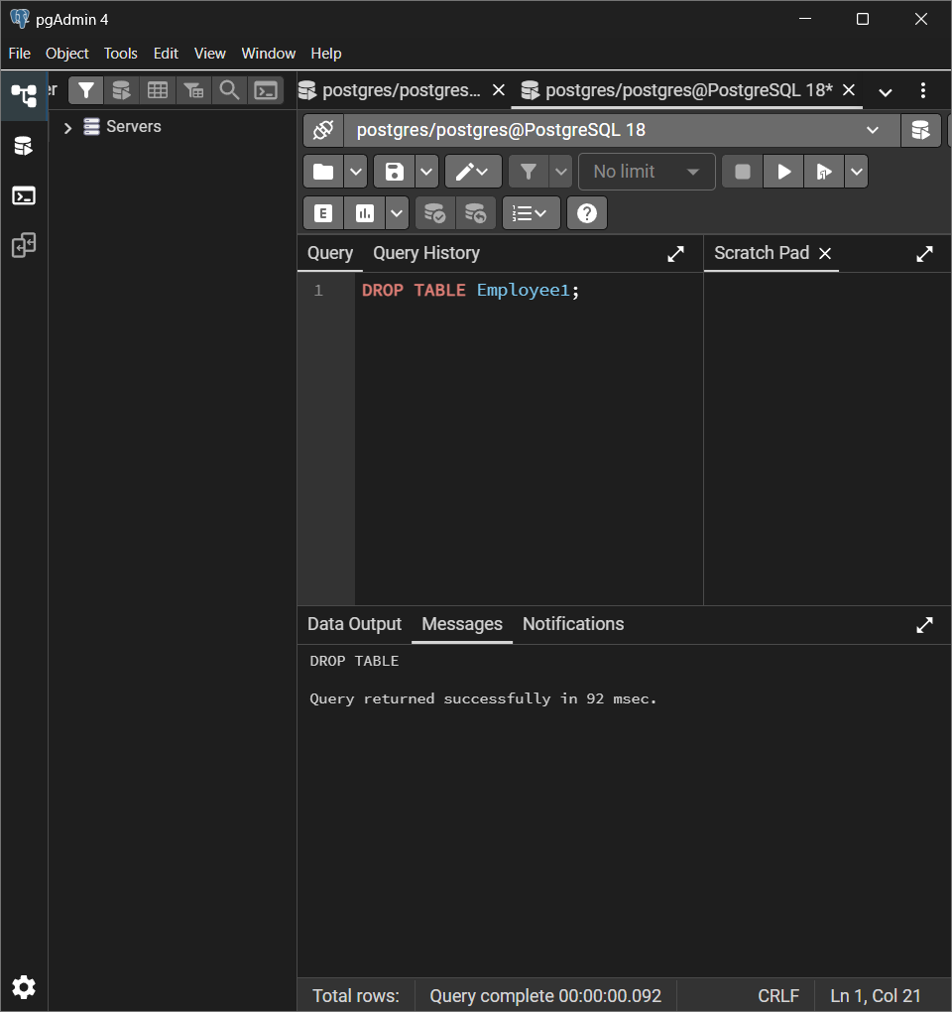

*2. Student Table*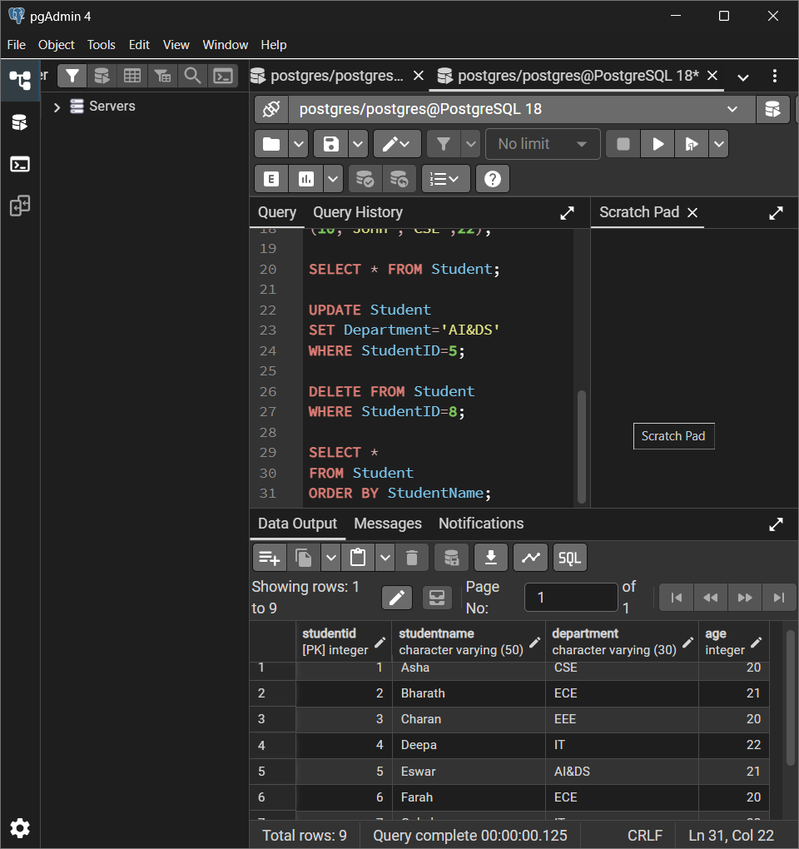
*3. SQL Filtering*
Practice using:
* WHERE-- The WHERE clause filters records based on a condition.
SELECT * FROM Employee
WHERE department=’IT’;
* LIKE
The LIKE operator searches for a specific pattern in text data.
W Wildcards Used with LIKE
% (Percentage)
Means zero or more characters.

SQL QUERIES:
SELECT * FROM Employee
WHERE EmpName LIKE 'A%'; -OUTPUT: ANU,ARUL

_ (Underscore)
Represents exactly one character.
Example:
SELECT *
FROM Employee
WHERE EmpName LIKE 'R____';
Matches names with 5 letters starting with R.
Example
Rahul

* BETWEEN
BETWEEN selects values within a given range.
Syntax
SELECT *
FROM Employee
WHERE Salary BETWEEN 50000 AND 70000;
* IN-- IN checks whether a value matches any value in a list.
SELECT * FROM Student
WHERE Department IN (‘IT’,’HR’)
* NOT IN --- NOT IN returns rows excluding the specified values.
Example
SELECT *
FROM Employee
WHERE Department NOT IN ('Sales','Marketing');

* AND-- AND combines multiple conditions. All conditions must be true.
Example
SELECT *
FROM Employee
WHERE Department='IT'
AND Salary>60000;

* OR --- OR combines multiple conditions. At least one condition must be true.
Example
SELECT *
FROM Employee
WHERE Department='HR'
OR Department='Finance';

*4. Aggregate Functions*
Write queries using:
* COUNT()
SELECT COUNT(*) AS TotalEmployees FROM Employee;
* SUM()
SELECT SUM(Salary) AS TotalSalary FROM Employee;
* AVG()
SELECT AVG(SALARY) AS TotalSalary FROM Employee;
* MIN()
SELECT MIN(Salary) AS MinimumSalary FROM Employee;
* MAX()
SELECT MAX(Salary) AS MinimumSalary FROM Employee;

5. GROUP BY & HAVING*
Write queries to:
* Count employees in each department.
SELECT Department COUNT(*)
FROM Employee
GROUP BY Department;

* Find the average salary for each department.
SELECT Department, AVG(Salary)
FROM Employee
GROUP BY Department;

* Find the total salary for each department.
SELECT Department,SUM(Salary)
FROM Employee
GROUP BY Department;
* Display only departments whose average salary is greater than a specific value.
SELECT Department, AVG(Salary)
FROM Employee
GROUP BY Department HAVING AVG(Salary)>55000;

*6. SQL JOINs*
Create *Employee* and *Department* tables and practice:
* INNER JOIN
SELECT EmpName,DeptName
FROM Employee
INNER JOIN Department
ON Employee.DeptID=Department.DeptID;
* LEFT JOIN
SELECT EmpName,DeptName
FROM Employee
LEFT JOIN Department
ON Employee.DeptID=Department.DeptID;
* RIGHT JOIN
SELECT EmpName,DeptName
FROM Employee
RIGHT JOIN Department
ON Employee.DeptID=Department.DeptID;
* FULL OUTER JOIN
SELECT EmpName,DeptName
FROM Employee
FULL OUTER JOIN Department
ON Employee.DeptID=Department.DeptID;

7. Customer & Orders
* Create *Customer* and *Orders* tables and write queries to:
CREATE TABLE Customer(
CustomerID INT PRIMARY KEY,
CustomerName VARCHAR(50)
);

CREATE TABLE Orders(
OrderID INT PRIMARY KEY,
CustomerID INT,
Amount DECIMAL(10,2)
);

INSERT INTO Customer VALUES
(1,'Ravi'),
(2,'Priya'),
(3,'Arun'),
(4,'Sneha'),
(5,'Kiran');

INSERT INTO Orders VALUES
(101,1,5000),
(102,1,7000),
(103,2,3000),
(104,3,9000),
(105,3,2000),
(106,5,8000);

* Display customer orders.
SELECT CustomerName,OrderID,Amount
FROM Customer
INNER JOIN Orders
ON Customer.CustomerID=Orders.CustomerID;

* Find customers without orders.
SELECT CustomerName
FROM Customer
LEFT JOIN Orders
ON Customer.CustomerID=Orders.CustomerID
WHERE OrderID IS NULL;

* Calculate the total purchase amount for each customer.
SELECT CustomerName,SUM(Amount) AS TotalPurchase
FROM Customer
INNER JOIN Orders
ON Customer.CustomerID=Orders.CustomerID
GROUP BY CustomerName;

* Find the customer who spent the most.
SELECT CustomerName,SUM(Amount) AS TotalSpent
FROM Customer
INNER JOIN Orders
ON Customer.CustomerID=Orders.CustomerID
GROUP BY CustomerName
ORDER BY TotalSpent DESC
LIMIT 1;

*8. Advanced SQL Queries*
Write queries to:
* Find the second highest salary.
SELECT MAX(Salary)
FROM Employee
WHERE Salary<
(SELECT MAX(Salary) FROM Employee);

* Find the third highest salary.
SELECT MAX(Salary)
FROM Employee
WHERE Salary<
(
SELECT MAX(Salary)
FROM Employee
WHERE Salary<
(
SELECT MAX(Salary)
FROM Employee
)
);

* Display the top 5 highest-paid employees.
SELECT *
FROM Employee
ORDER BY Salary DESC
LIMIT 5;

* Find employees earning more than the average salary.
SELECT *
FROM Employee
WHERE Salary>
(
SELECT AVG(Salary)
FROM Employee
);

9. Subqueries
Above Average Salary
SELECT *
FROM Employee
WHERE Salary>
(
SELECT AVG(Salary)
FROM Employee
);
Department with Highest Average Salary
SELECT Department,AVG(Salary)
FROM Employee
GROUP BY Department
ORDER BY AVG(Salary) DESC
LIMIT 1;
Compare Salary Within Department
SELECT *
FROM Employee e
WHERE Salary>
(
SELECT AVG(Salary)
FROM Employee
WHERE Department=e.Department
);
10. Mini SQL Challenge
Highest Average Salary Department
SELECT Department,AVG(Salary)
FROM Employee
GROUP BY Department
ORDER BY AVG(Salary) DESC
LIMIT 1;
Employees Earning More Than Department Average
SELECT *
FROM Employee e
WHERE Salary>
(
SELECT AVG(Salary)
FROM Employee
WHERE Department=e.Department
);
Customers With More Than Two Orders
SELECT CustomerID,COUNT(*)
FROM Orders
GROUP BY CustomerID
HAVING COUNT(*)>2;
Products Never Ordered
CREATE TABLE Product(
ProductID INT PRIMARY KEY,
ProductName VARCHAR(50)
);

INSERT INTO Product VALUES
(1,'Laptop'),
(2,'Mouse'),
(3,'Keyboard'),
(4,'Monitor');

ALTER TABLE Orders
ADD ProductID INT;

UPDATE Orders SET ProductID=1 WHERE OrderID=101;
UPDATE Orders SET ProductID=2 WHERE OrderID=102;
UPDATE Orders SET ProductID=1 WHERE OrderID=103;
UPDATE Orders SET ProductID=3 WHERE OrderID=104;
UPDATE Orders SET ProductID=2 WHERE OrderID=105;
UPDATE Orders SET ProductID=3 WHERE OrderID=106;

SELECT ProductName
FROM Product
WHERE ProductID NOT IN
(
SELECT ProductID
FROM Orders
WHERE ProductID IS NOT NULL
);
Second Highest Salary Without Using LIMIT
SELECT MAX(Salary)
FROM Employee
WHERE Salary<
(
SELECT MAX(Salary)
FROM Employee
);
This scri

